**Tasks Group Project week 13/11/23**

**Tasks**

1. Experiment with example implementations ( [Autoencoder-on-MNIST-in-Pytorch/Autoencoder.py at master · SuchismitaSahu1993/Autoencoder-on-MNIST-in-Pytorch · GitHub](https://github.com/SuchismitaSahu1993/Autoencoder-on-MNIST-in-Pytorch/blob/master/Autoencoder.py))
2. Research software libraries (TensorFlow, Pytorch, Flux)
   1. TensorFlow ([Intro to Autoencoders  |  TensorFlow Core](https://www.tensorflow.org/tutorials/generative/autoencoder) ;

[tensorflow · PyPI](https://pypi.org/project/tensorflow/) ;

[tfae · PyPI](https://pypi.org/project/tfae/) extension)

pip install tensorflow

pip install tfae

* 1. Pytorch ([GitHub - dariocazzani/pytorch-AE: Autoencoders in PyTorch](https://github.com/dariocazzani/pytorch-AE)

[torch · PyPI](https://pypi.org/project/torch/))

mkvirtualenv --python=/usr/bin/python3 pytorch-AE

pip install torch torchvision

python train.py --help

pip install pythae

**errors** [python - PyTorch RuntimeError: DataLoader worker (pid(s) 15332) exited unexpectedly - Stack Overflow](https://stackoverflow.com/questions/60101168/pytorch-runtimeerror-dataloader-worker-pids-15332-exited-unexpectedly)

soln

num_workers=0

**examples**

[GitHub - pytorch/examples: A set of examples around pytorch in Vision, Text, Reinforcement Learning, etc.](https://github.com/pytorch/examples)

**Tutorial**

[Welcome to PyTorch Tutorials — PyTorch Tutorials 2.1.1+cu121 documentation](https://pytorch.org/tutorials/)

* 1. Flux – *Julia* - ([GitHub - alecokas/flux-vae: Implementation of a Convolutional Variational Autoencoder in Flux.jl](https://github.com/alecokas/flux-vae))

1. Write an AE document on the function of each layer of the network.
2. Install libraries as appropriate
3. Configure a network for 2 central neurons.
4. Train network on MNIST dataset (32x32 images) ([MNIST handwritten digit database, Yann LeCun, Corinna Cortes and Chris Burges](http://yann.lecun.com/exdb/mnist/)

[MNIST Dataset (kaggle.com)](https://www.kaggle.com/datasets/hojjatk/mnist-dataset/) )

1. Plot the 2 central neurons’ data in 2D.
2. *(Generate extra data)?*
3. Update the AE document with all the above completed (process/results/comparison etc)

**Splitting up work**

**Definitions**

[machine learning - Epoch vs Iteration when training neural networks - Stack Overflow](https://stackoverflow.com/questions/4752626/epoch-vs-iteration-when-training-neural-networks)

* one **epoch** = one forward pass and one backward pass of *all* the training examples
* **batch size** = the number of training examples in one forward/backward pass. The higher the batch size, the more memory space you'll need.
* number of **iterations** = number of passes, each pass using [batch size] number of examples. To be clear, one pass = one forward pass + one backward pass (we do not count the forward pass and backward pass as two different passes).

For example: if you have 1000 training examples, and your batch size is 500, then it will take 2 iterations to complete 1 epoch.

[The Difference Between Epoch and Iteration in Neural Networks | Baeldung on Computer Science](https://www.baeldung.com/cs/neural-networks-epoch-vs-iteration)

In pytorch, tensors are used rather than arrays or lists etc.

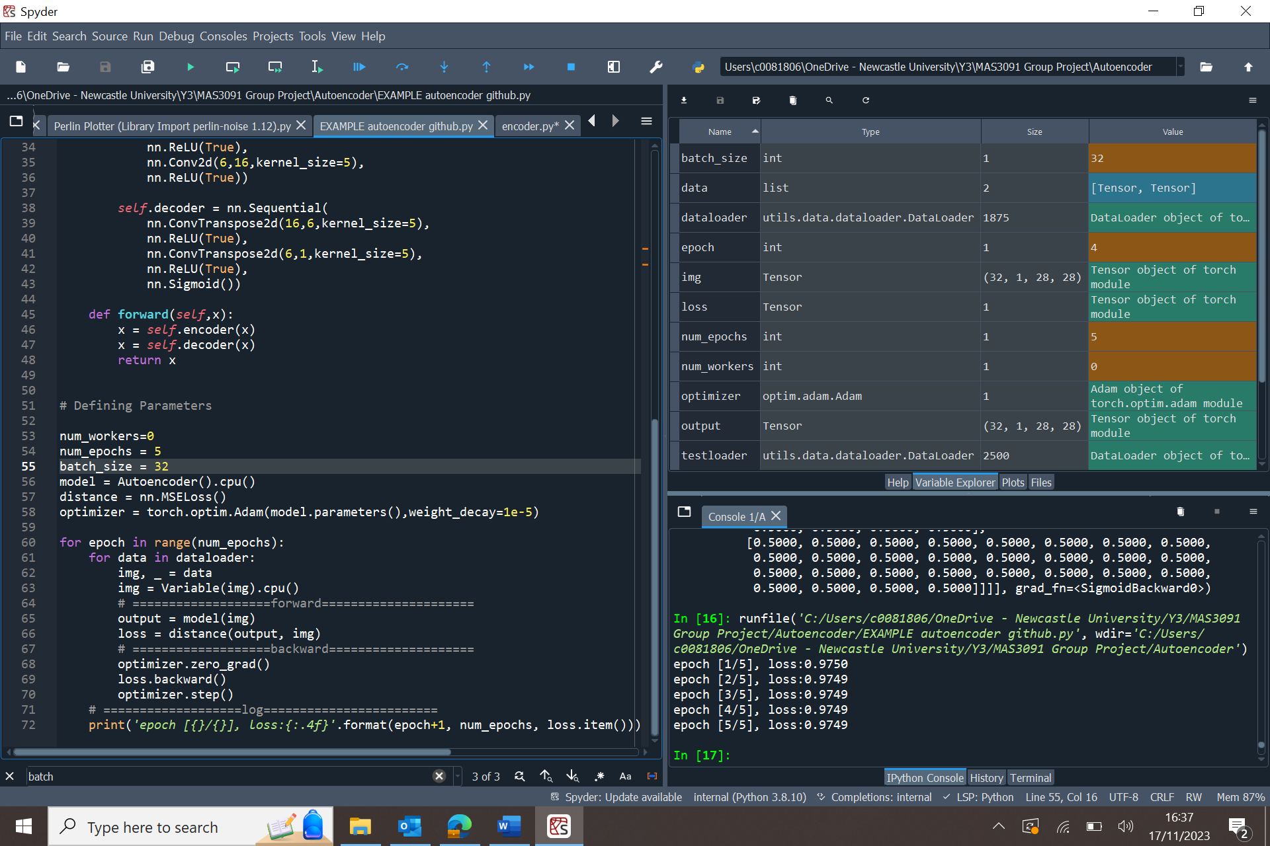

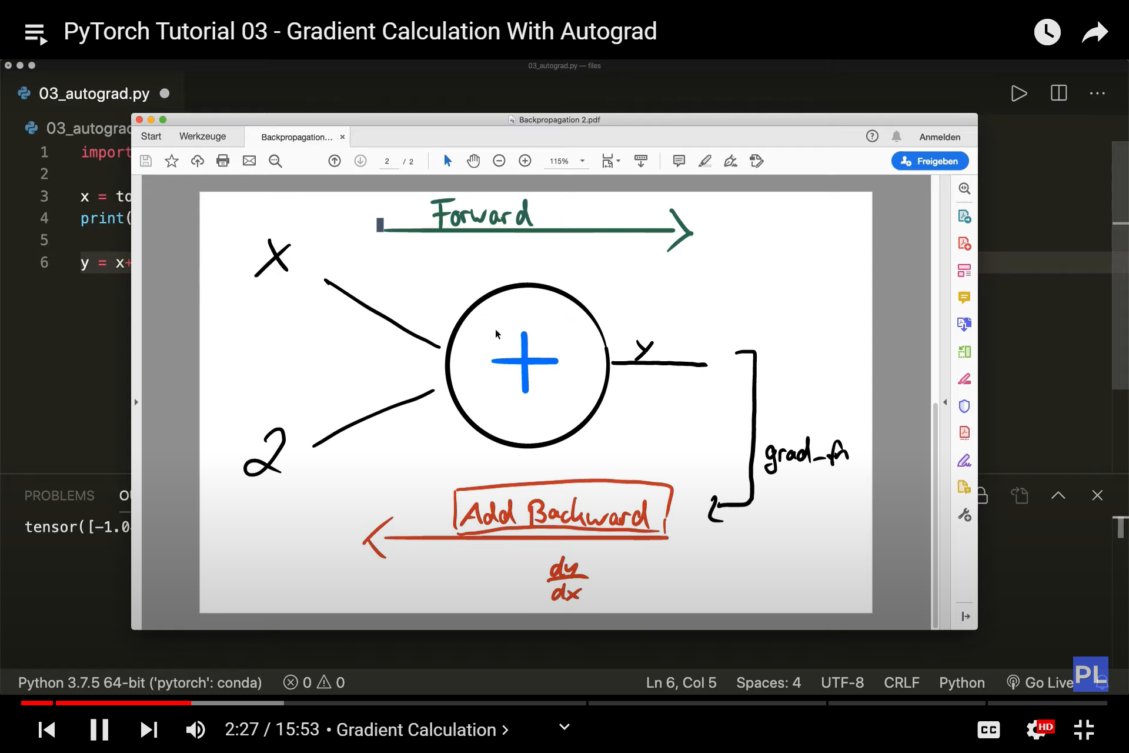

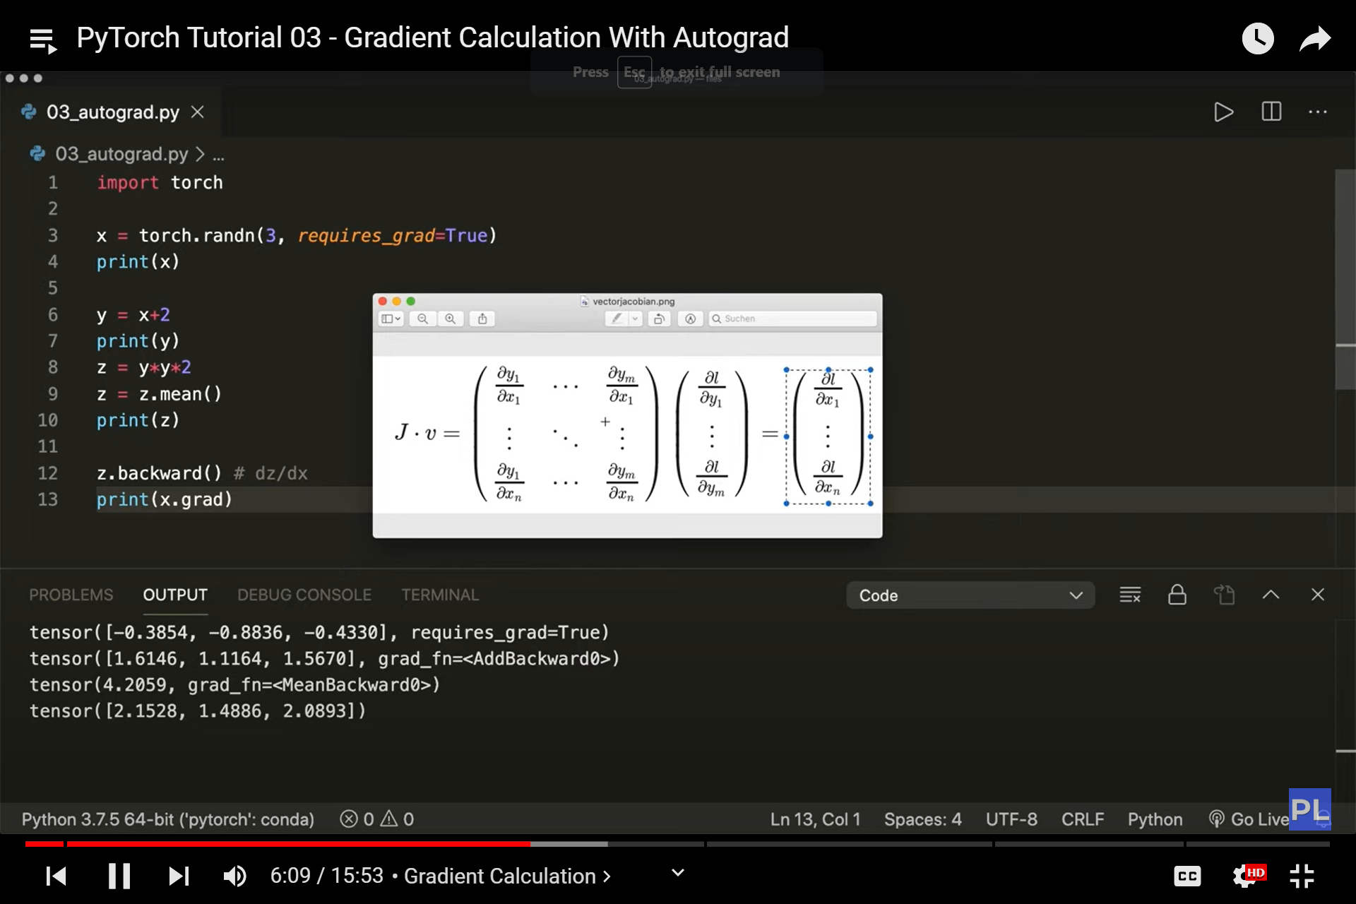

Jacobian matrix

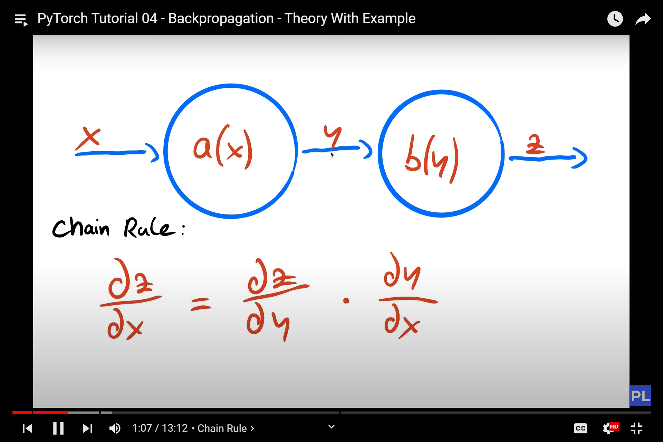

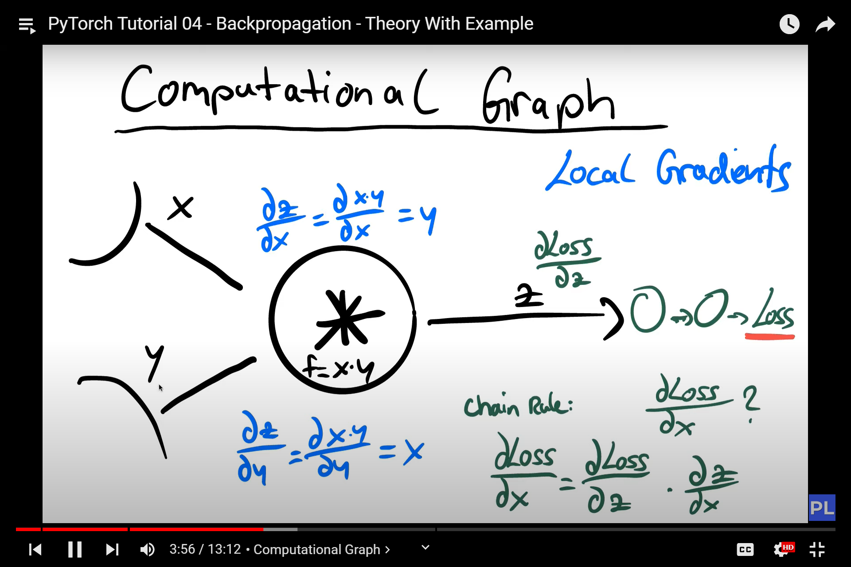

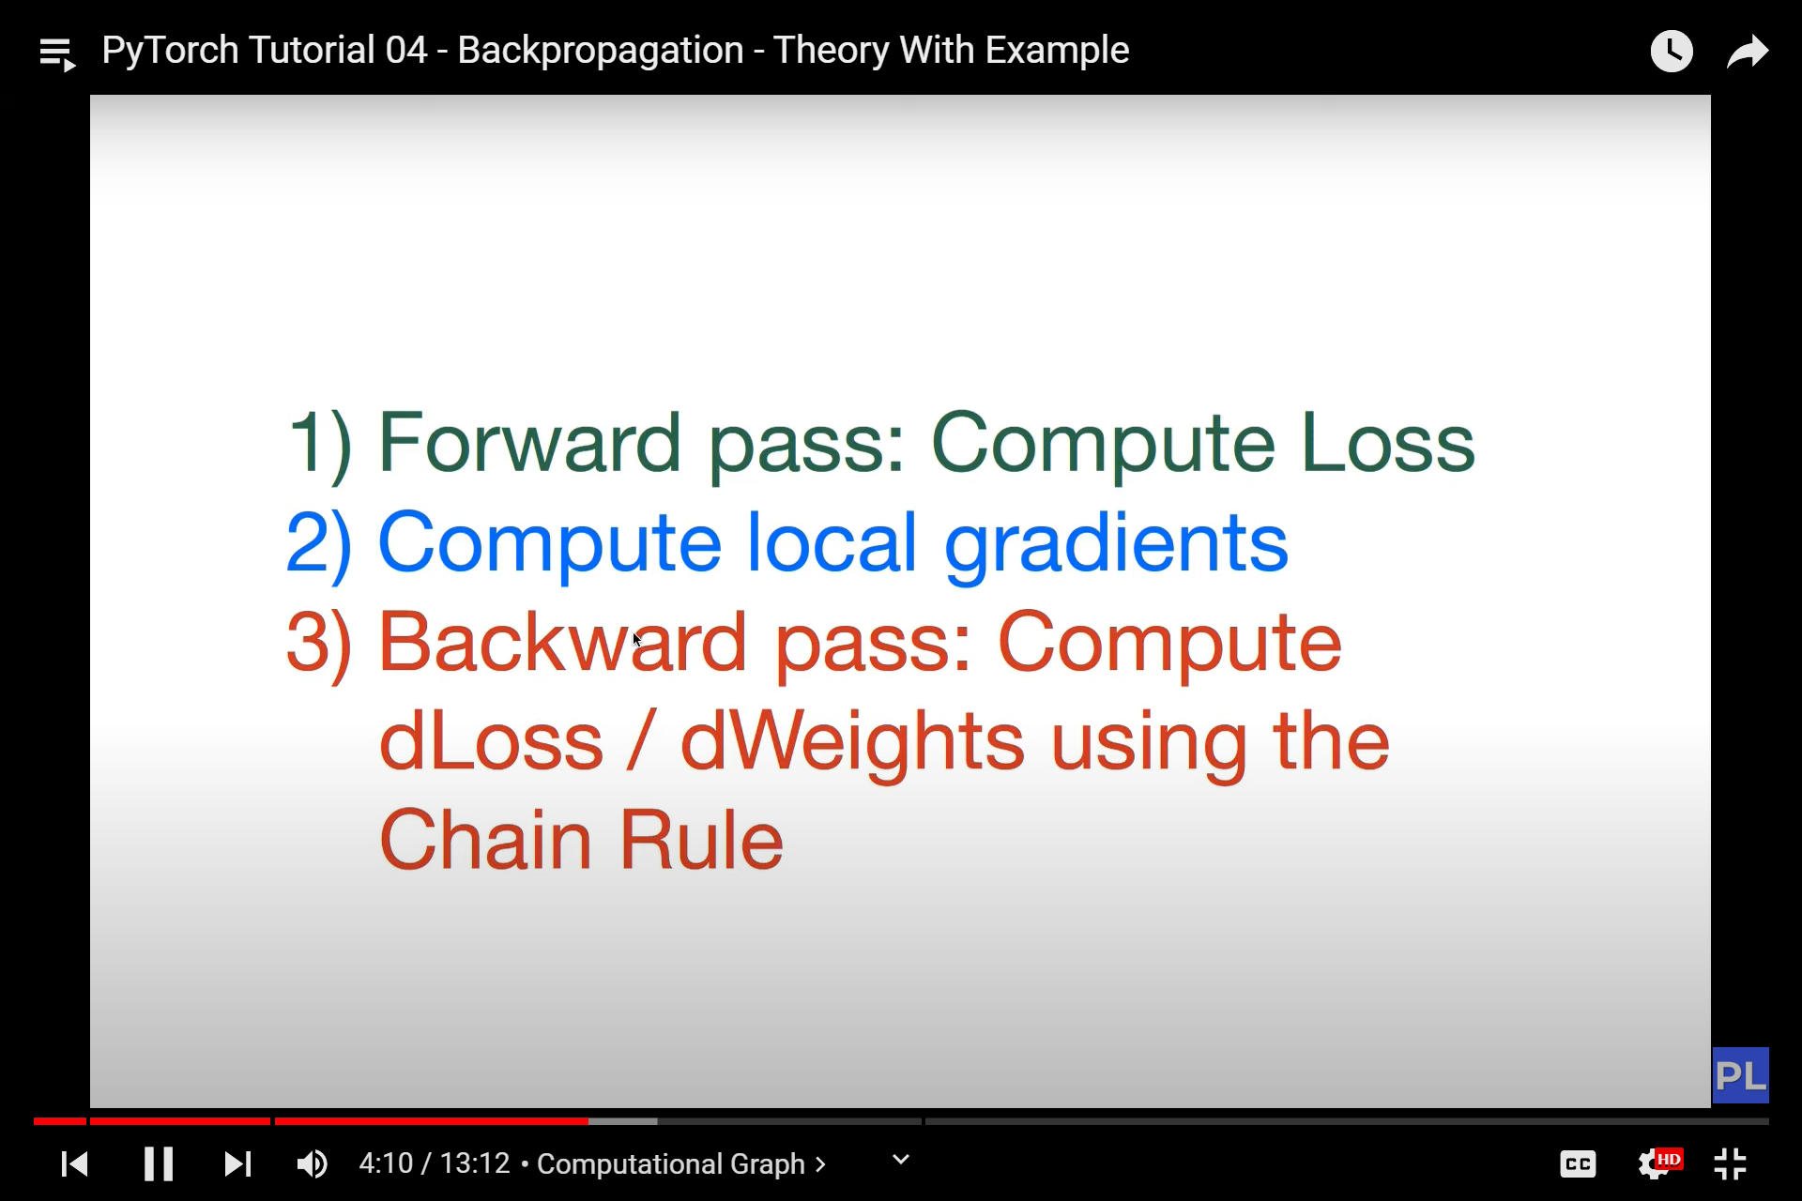

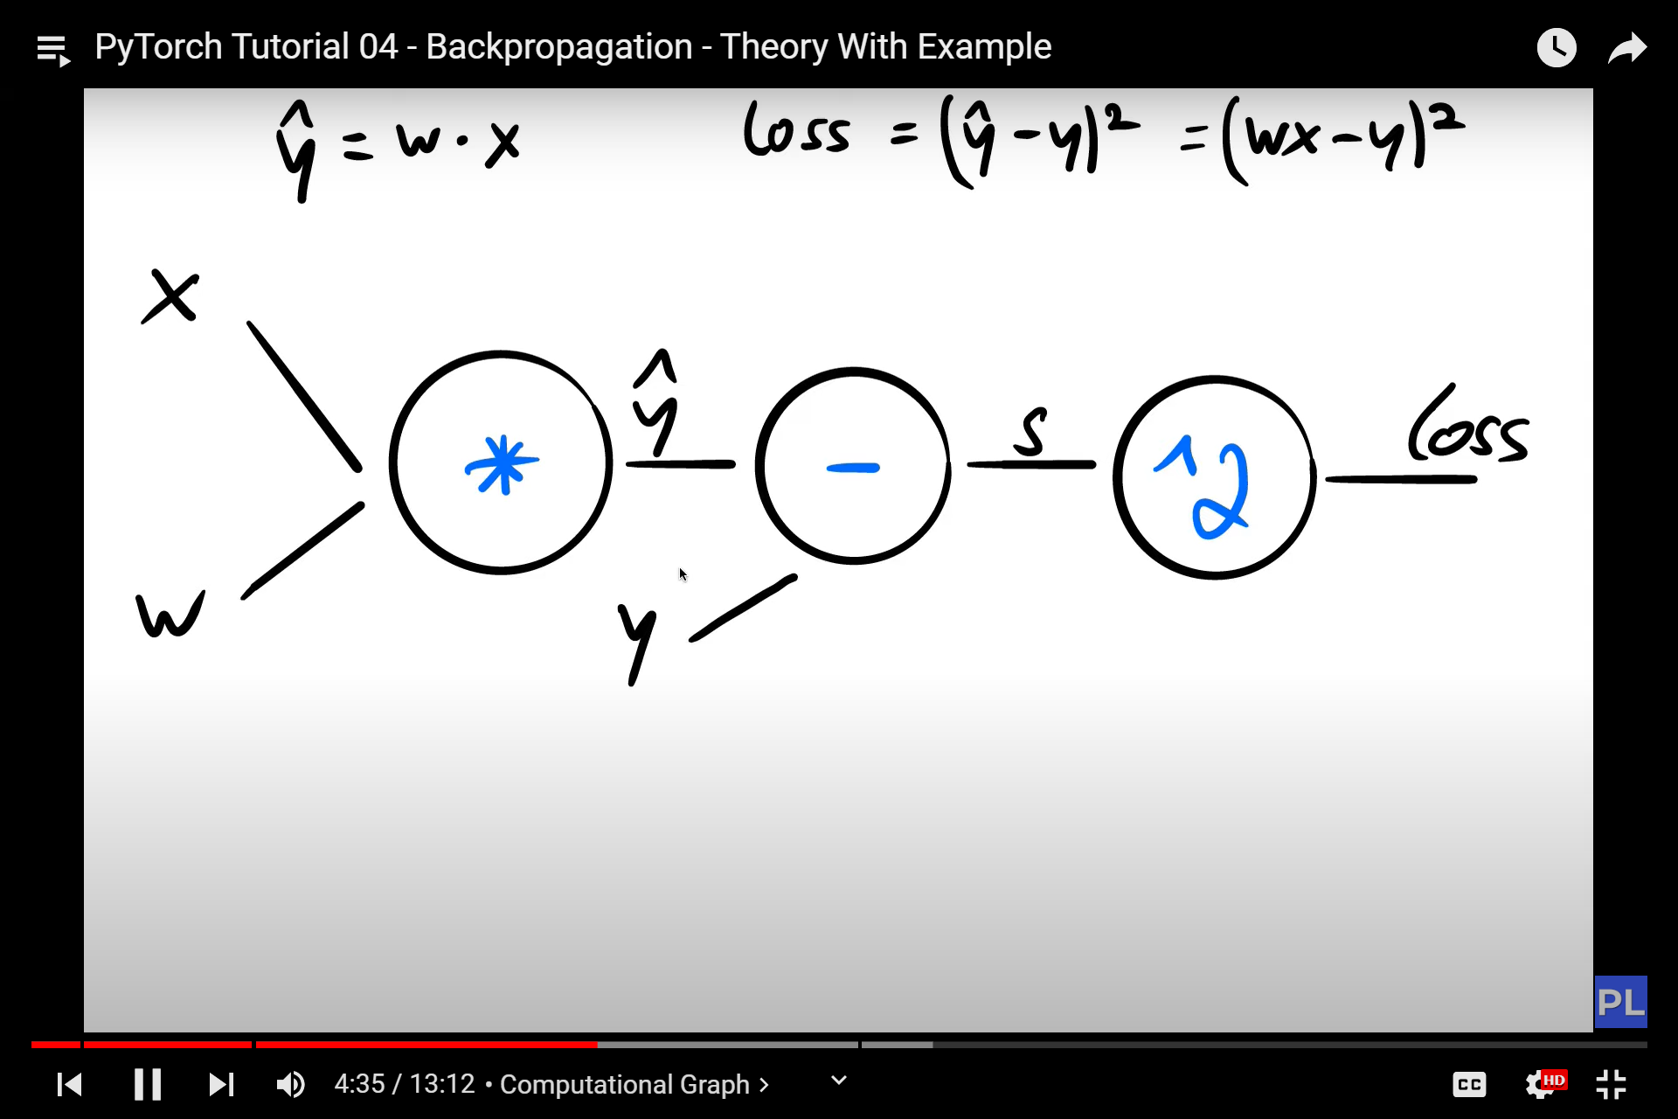

Linear regression

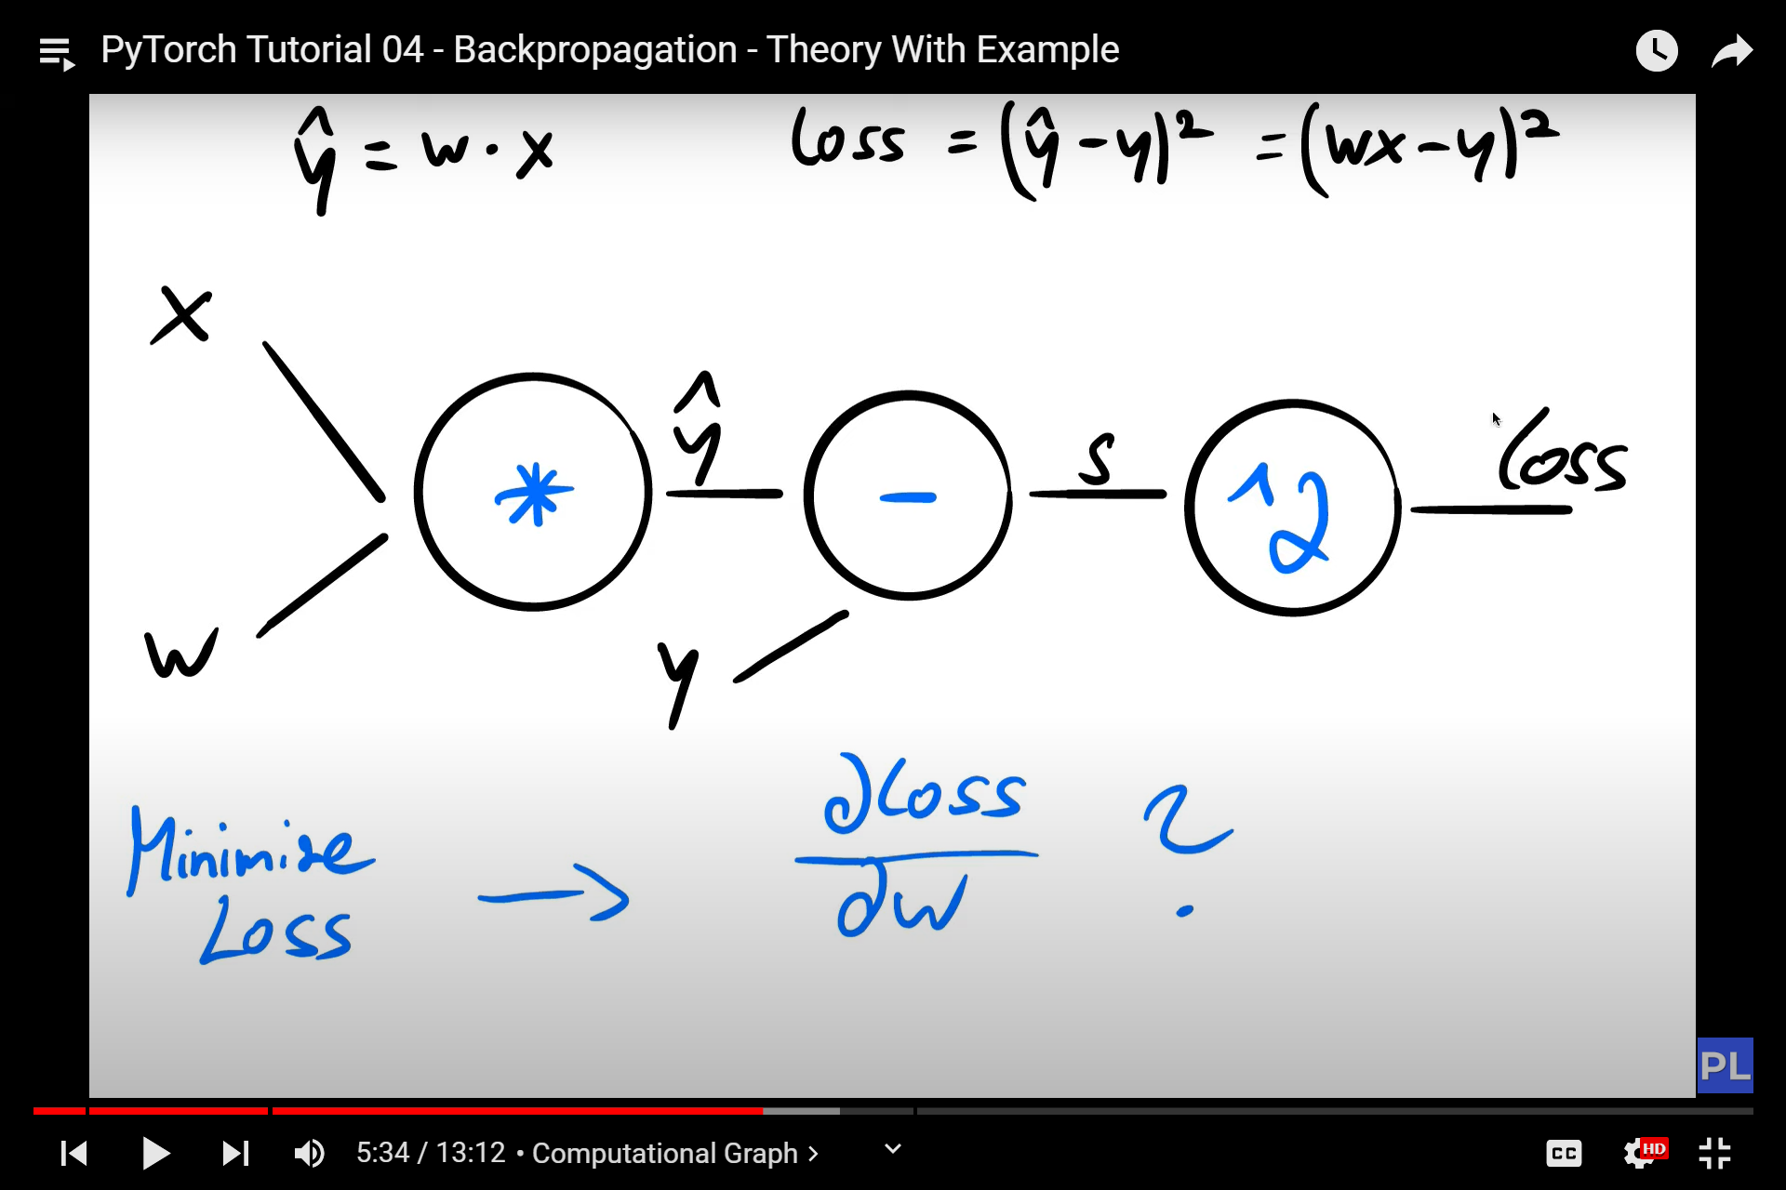

We want to minimize our loss wrt our weights

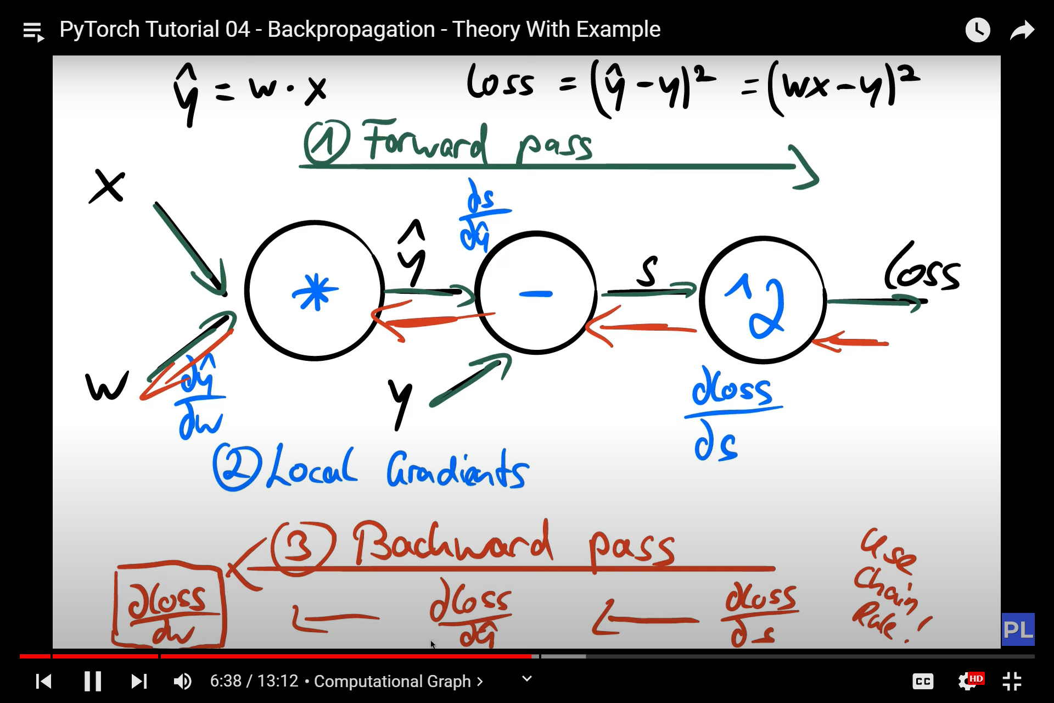

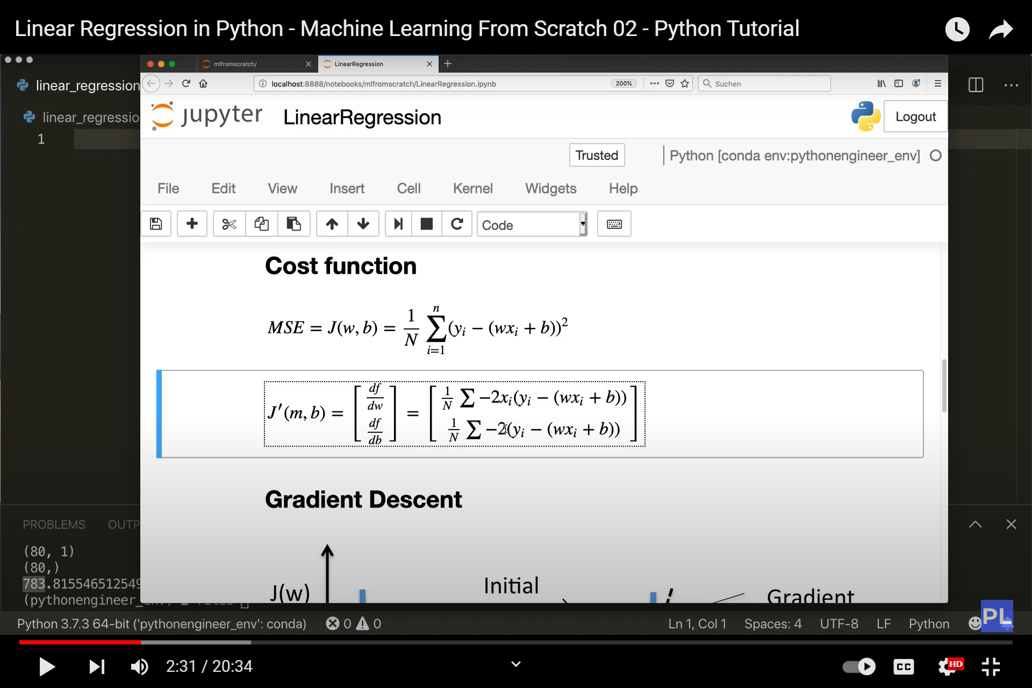

Cost function MSE

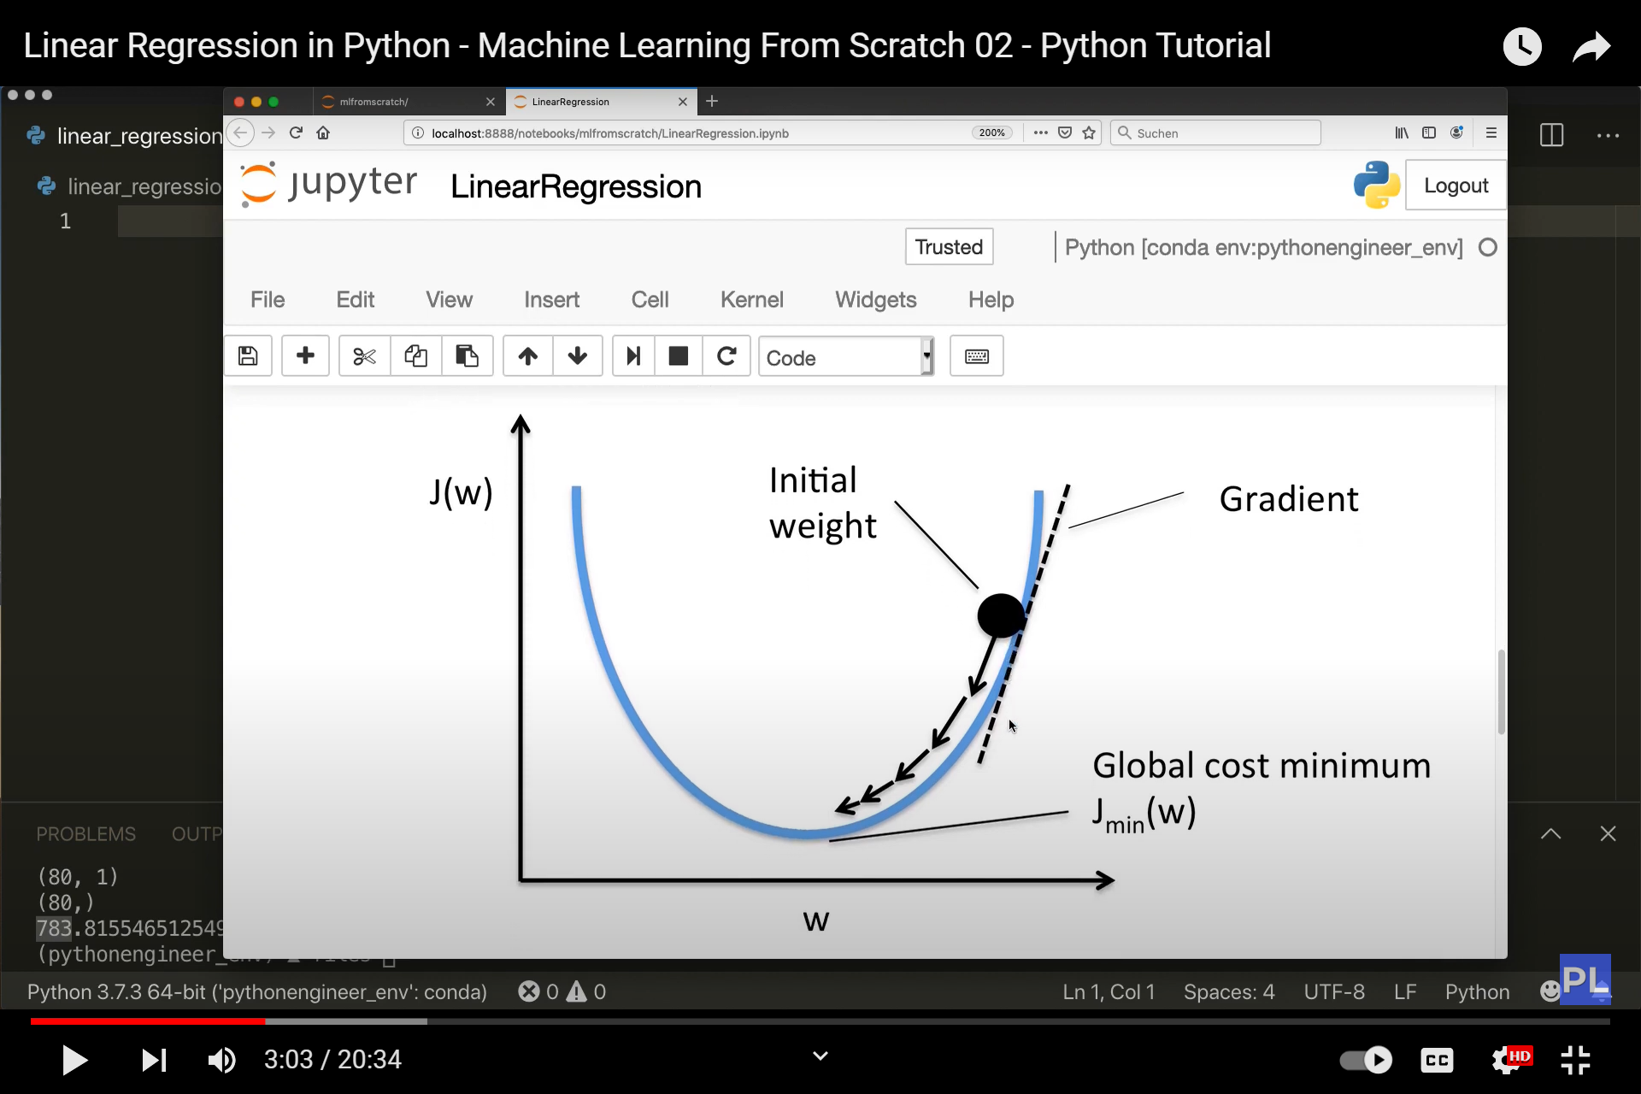

Gradient Descent

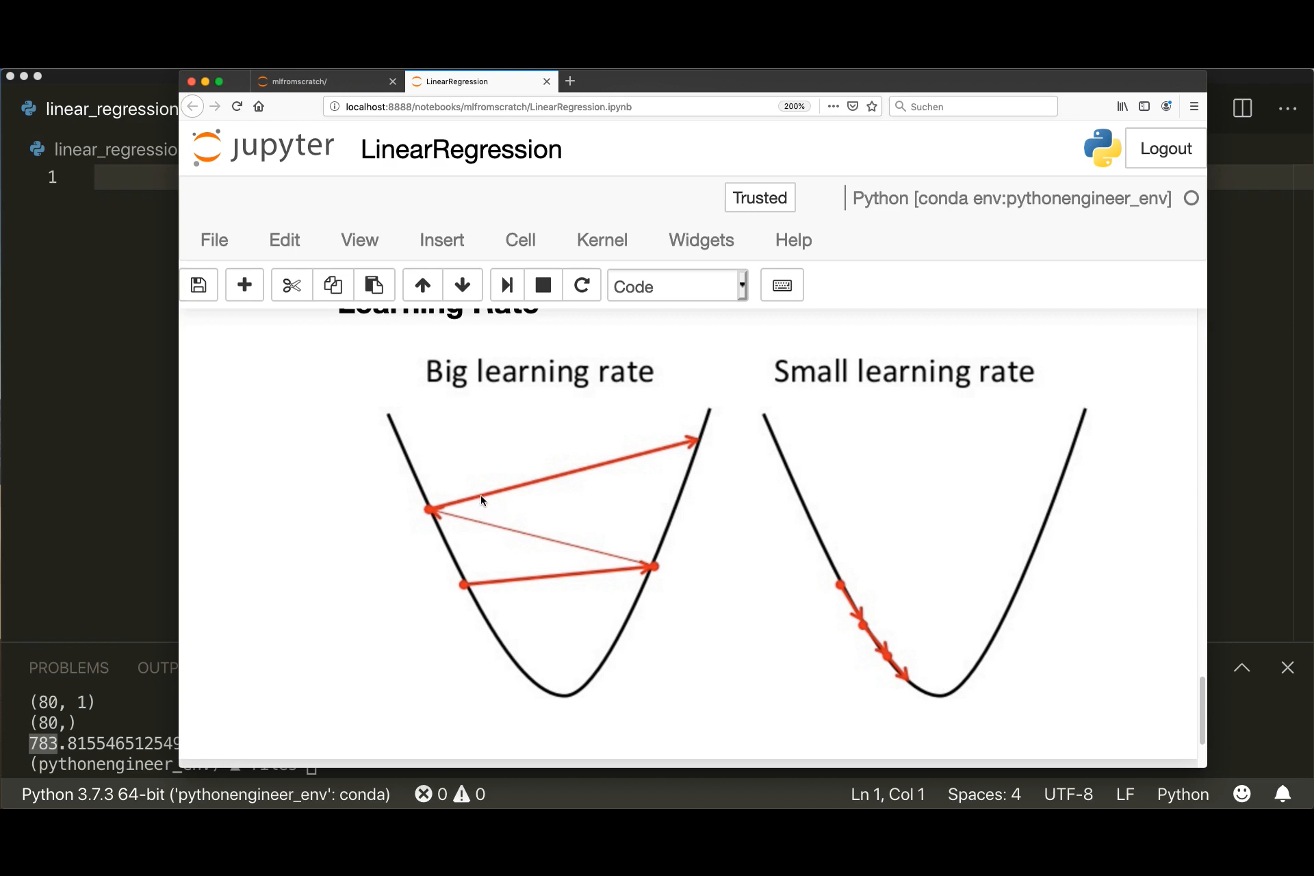

Learning rate

Gradient descent with numpy

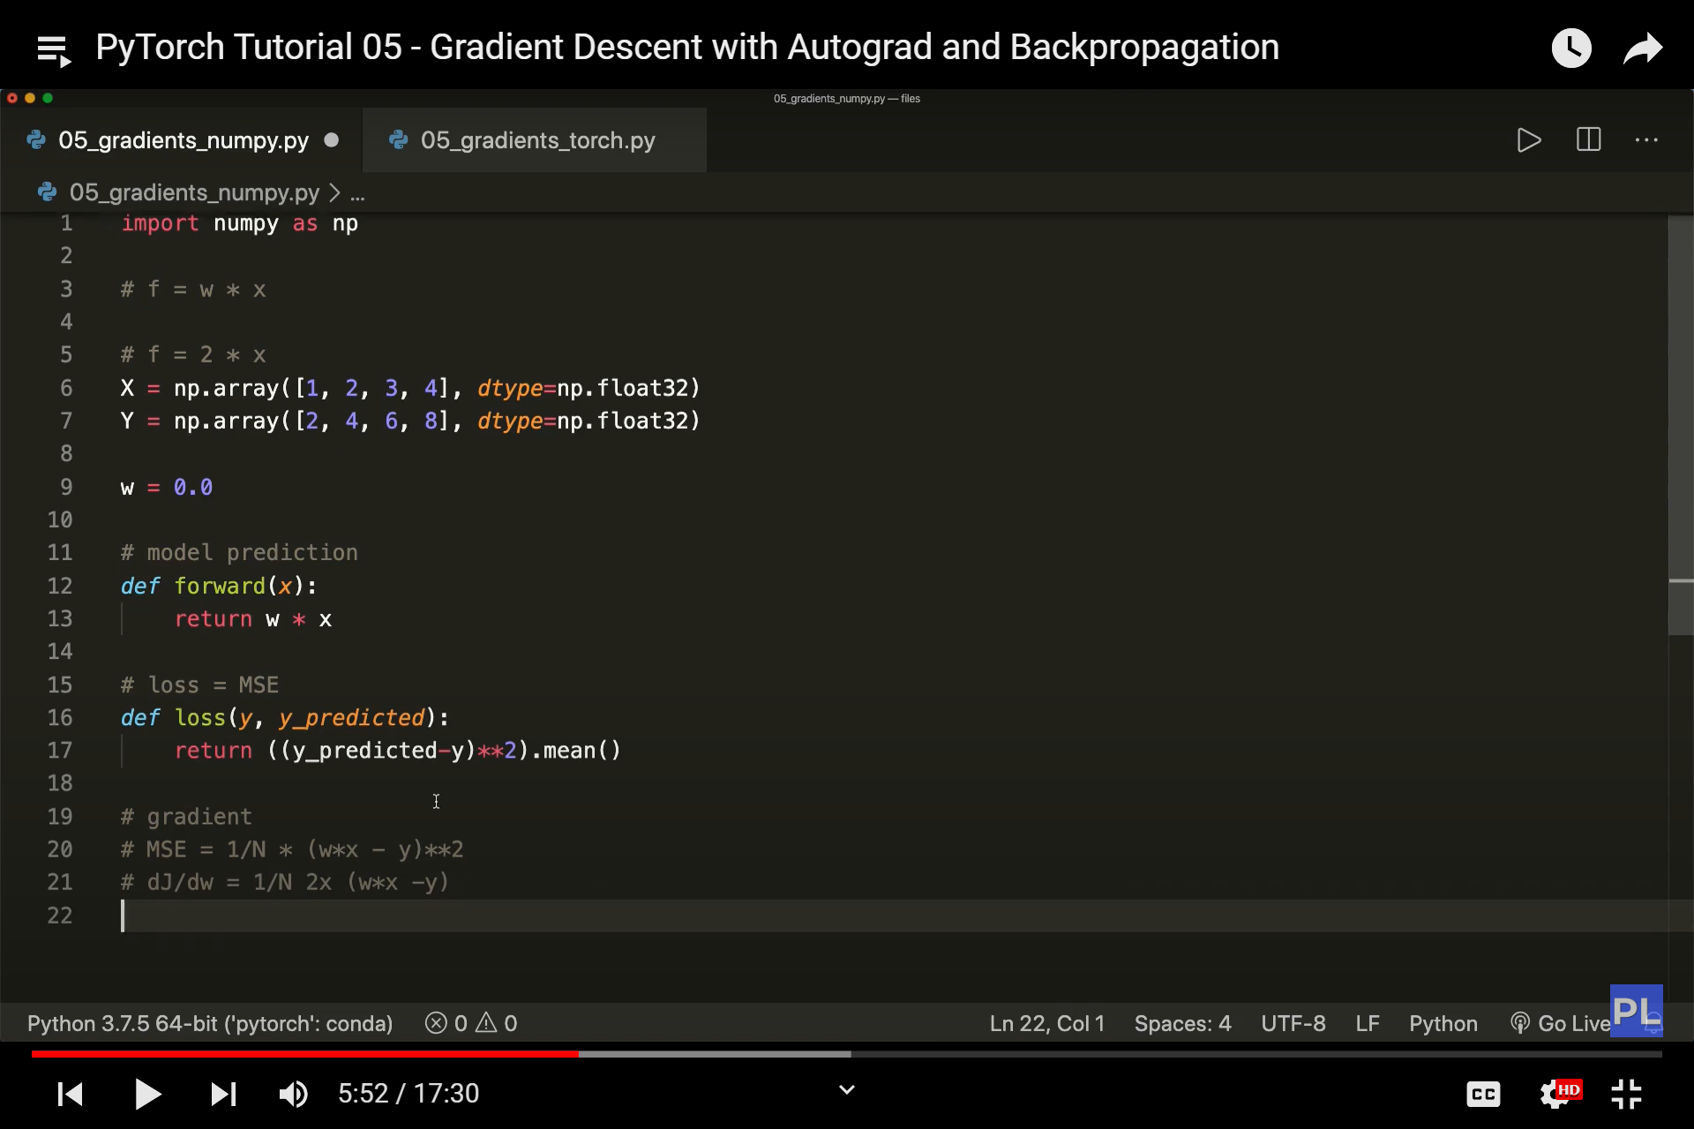

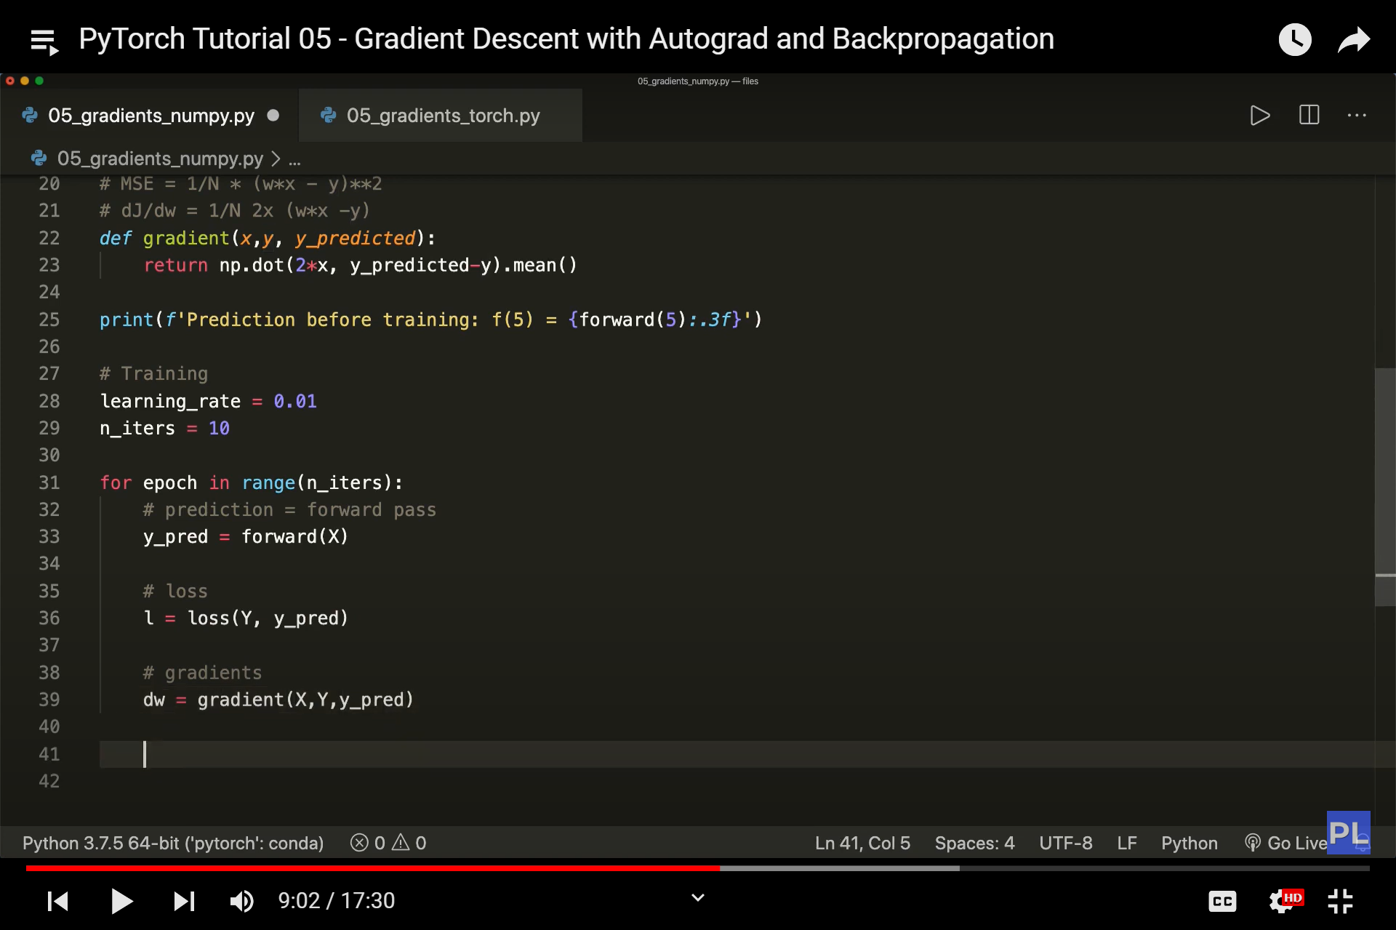

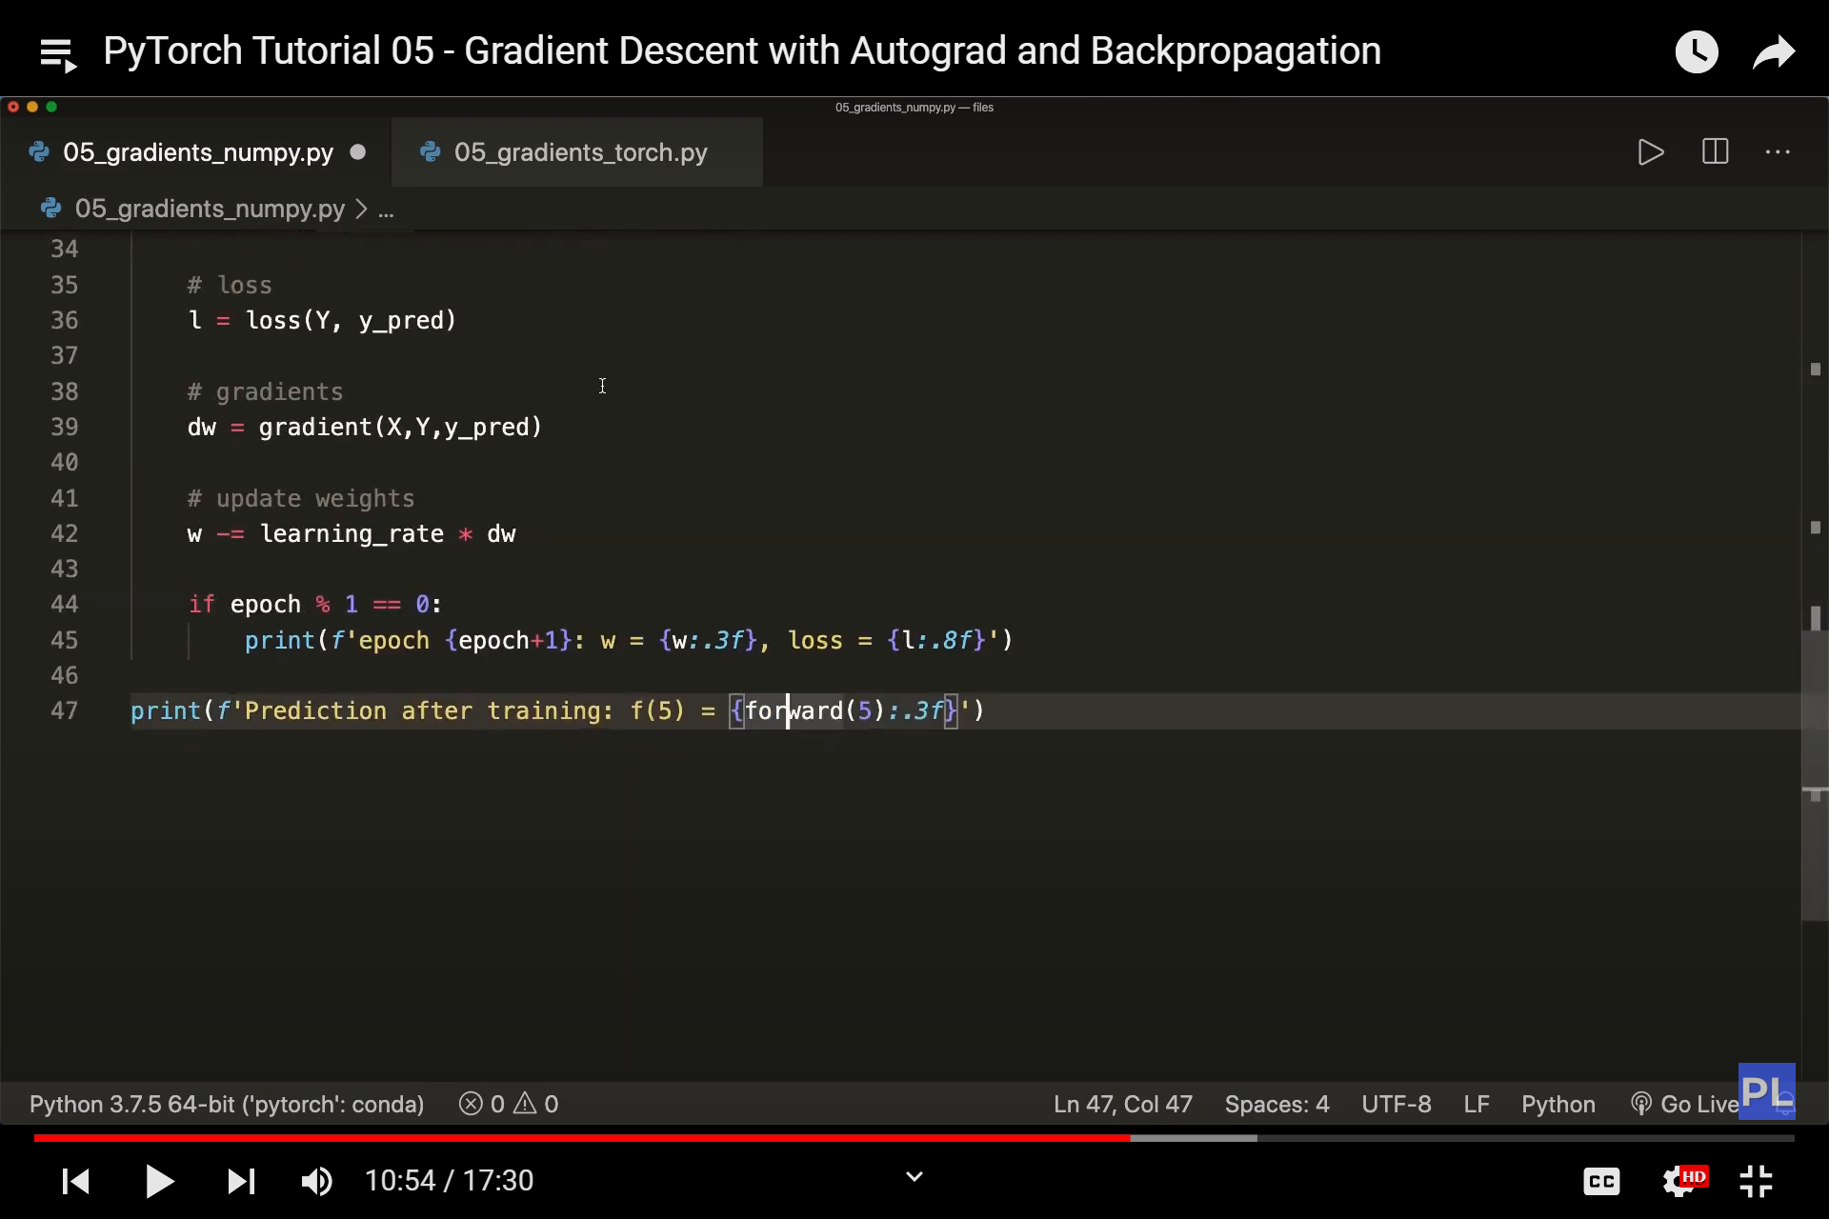

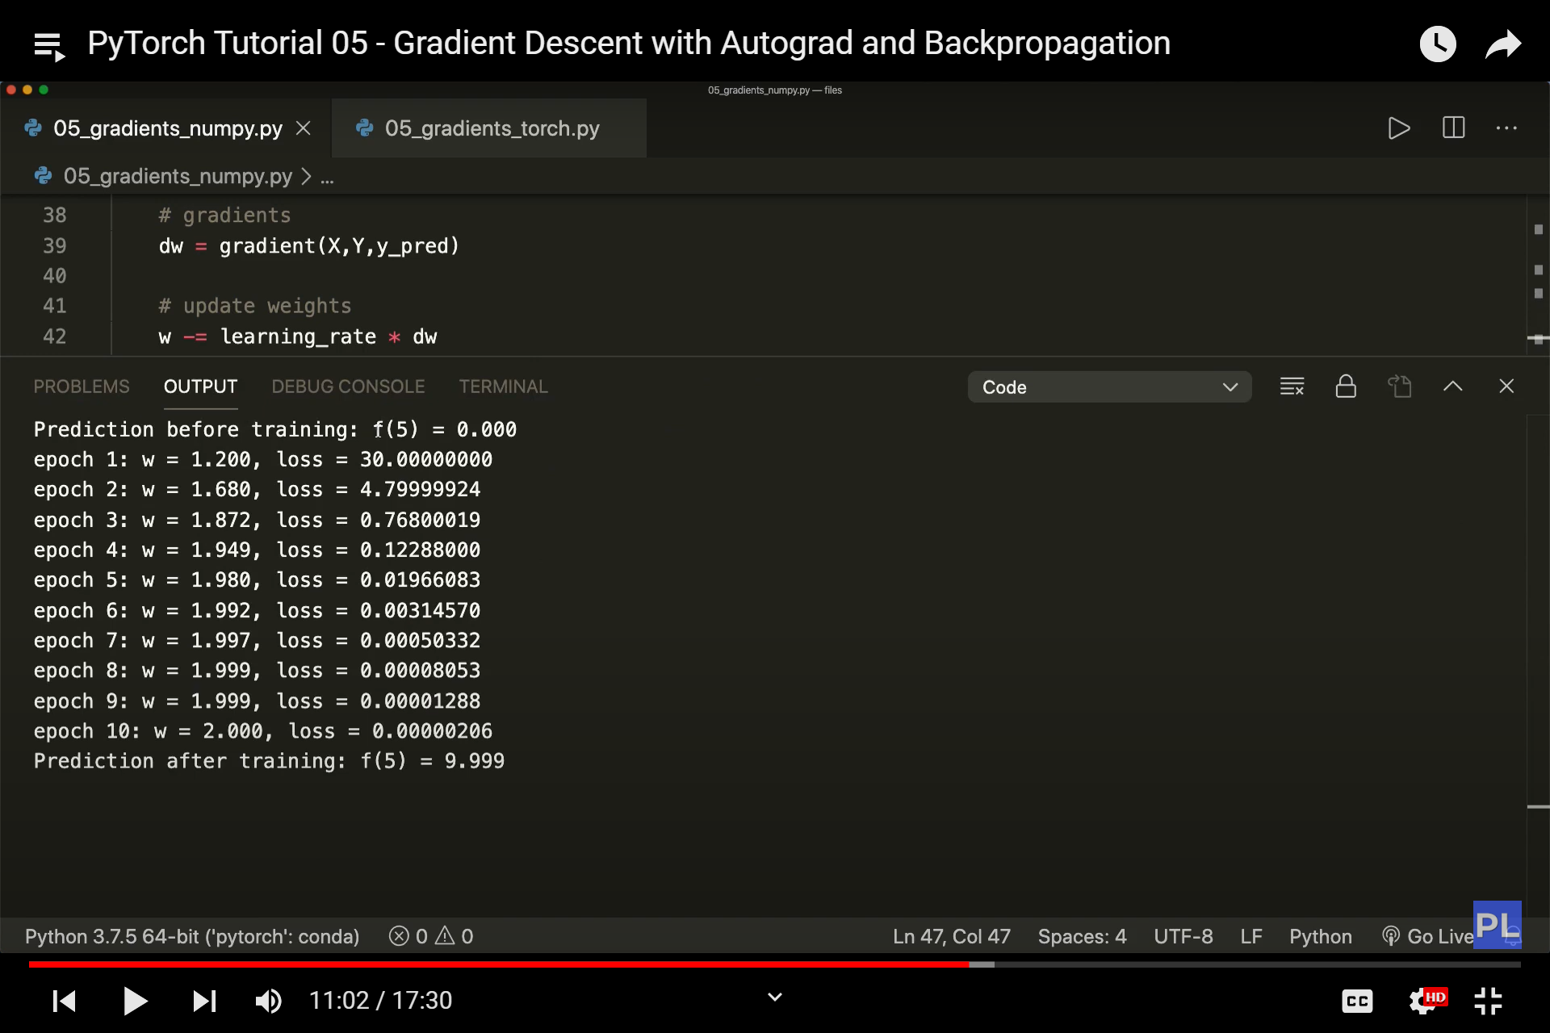

Gradient descent with torch

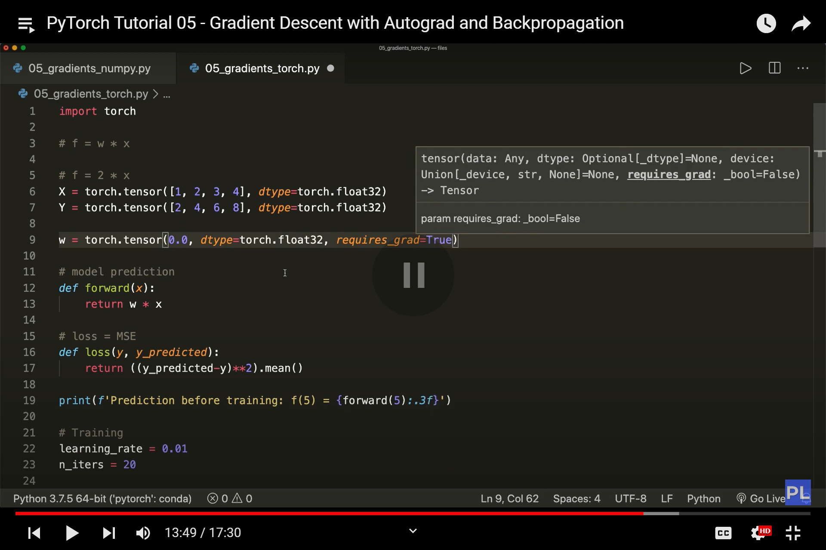

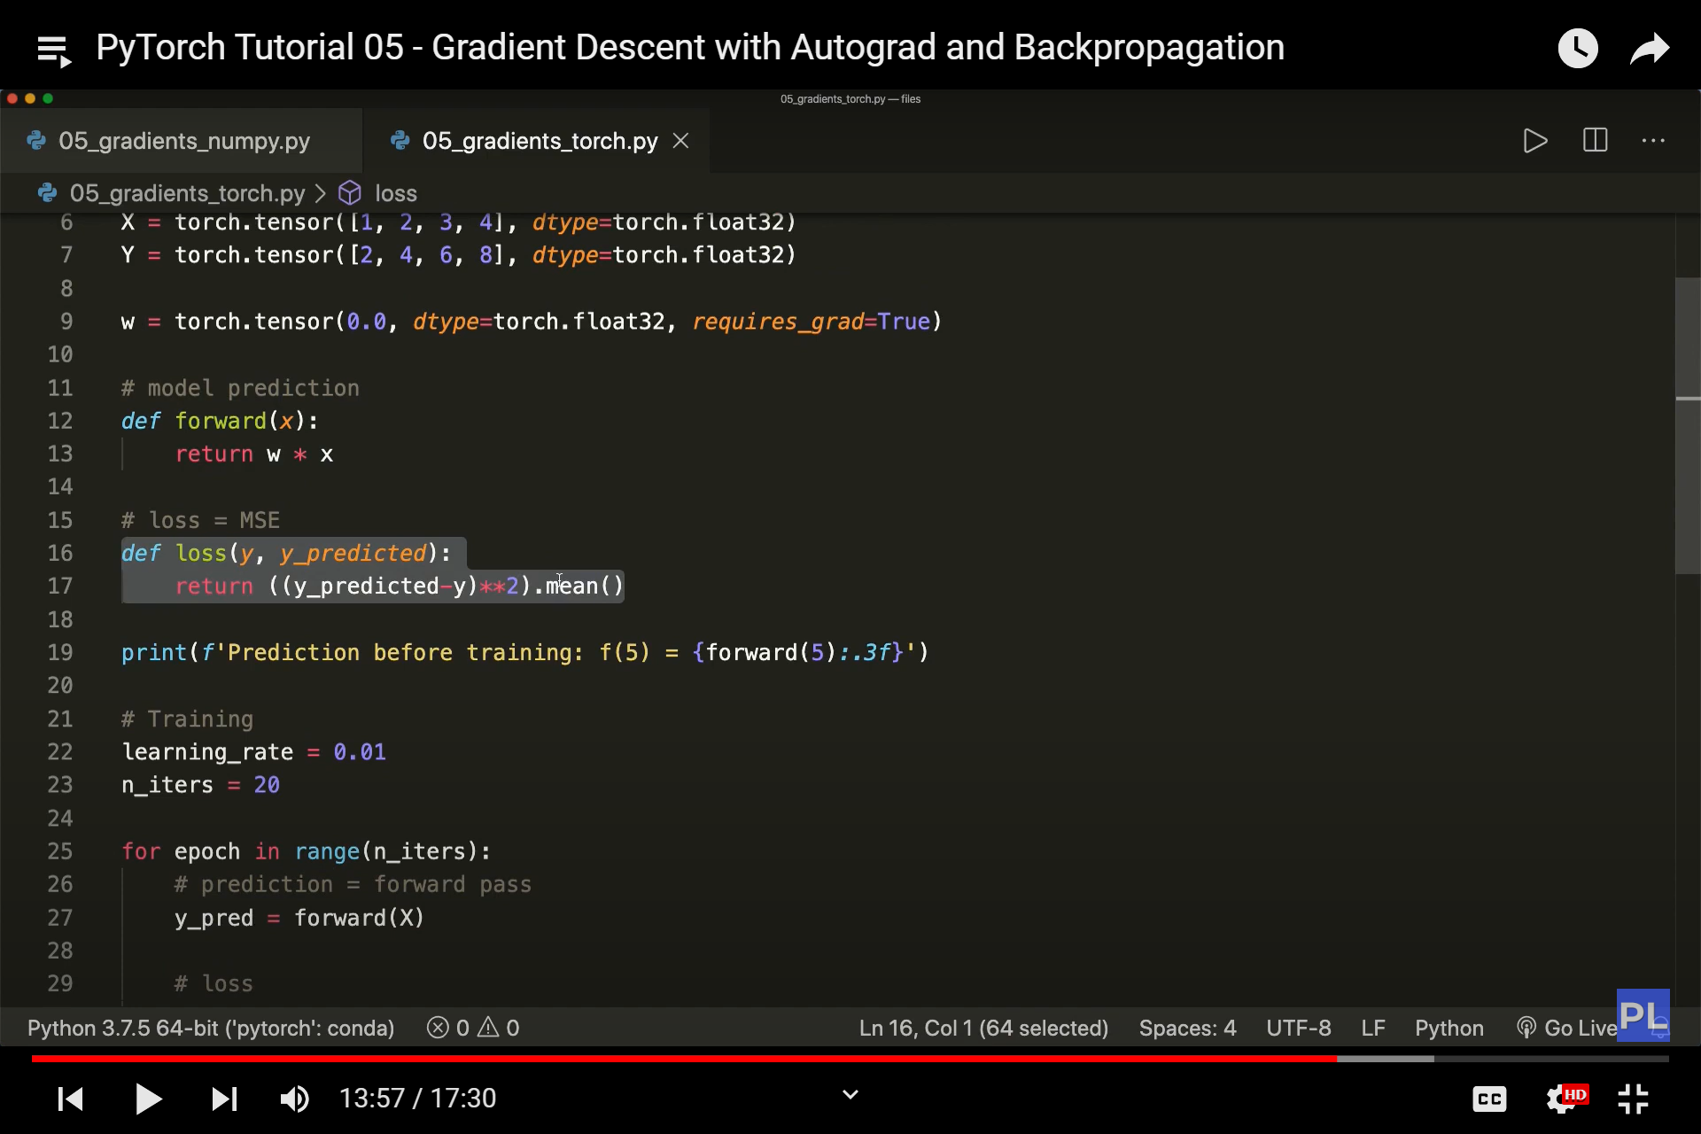

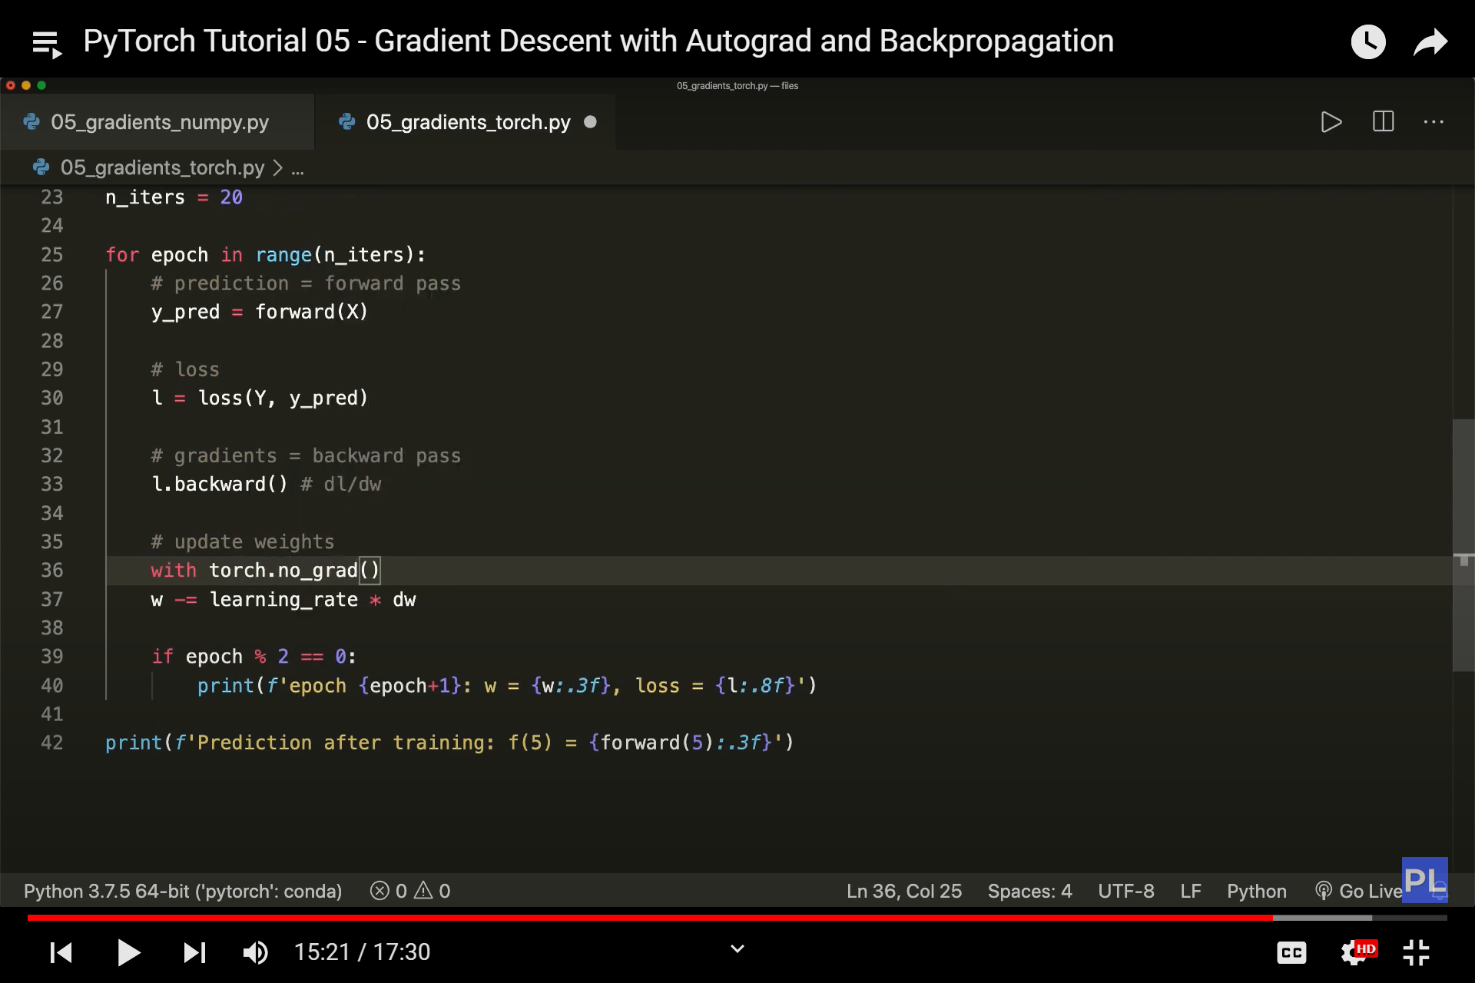

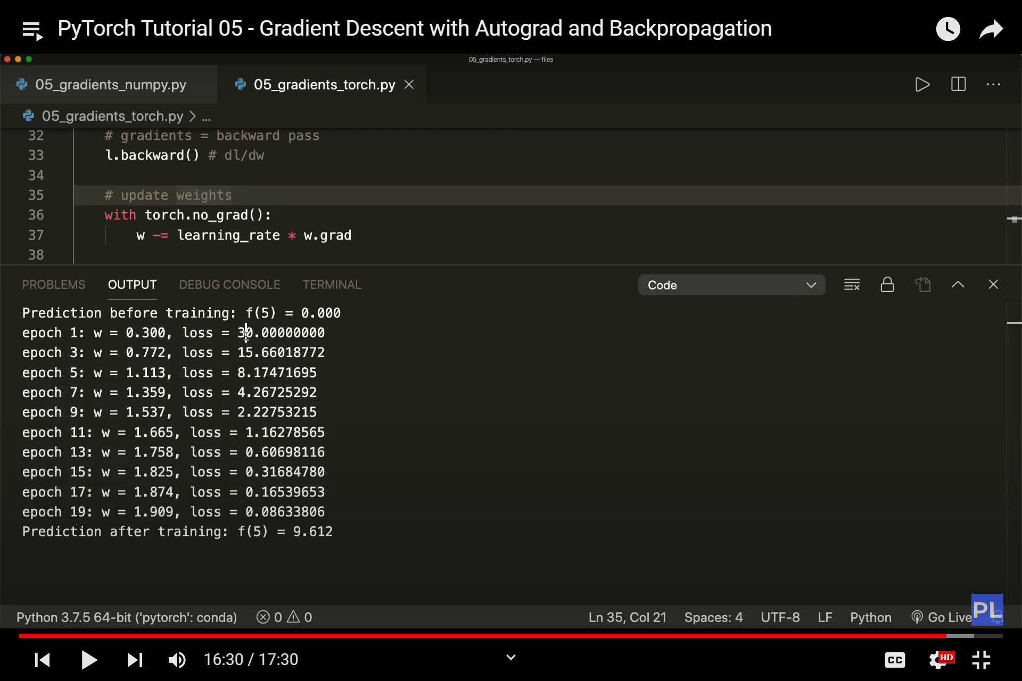

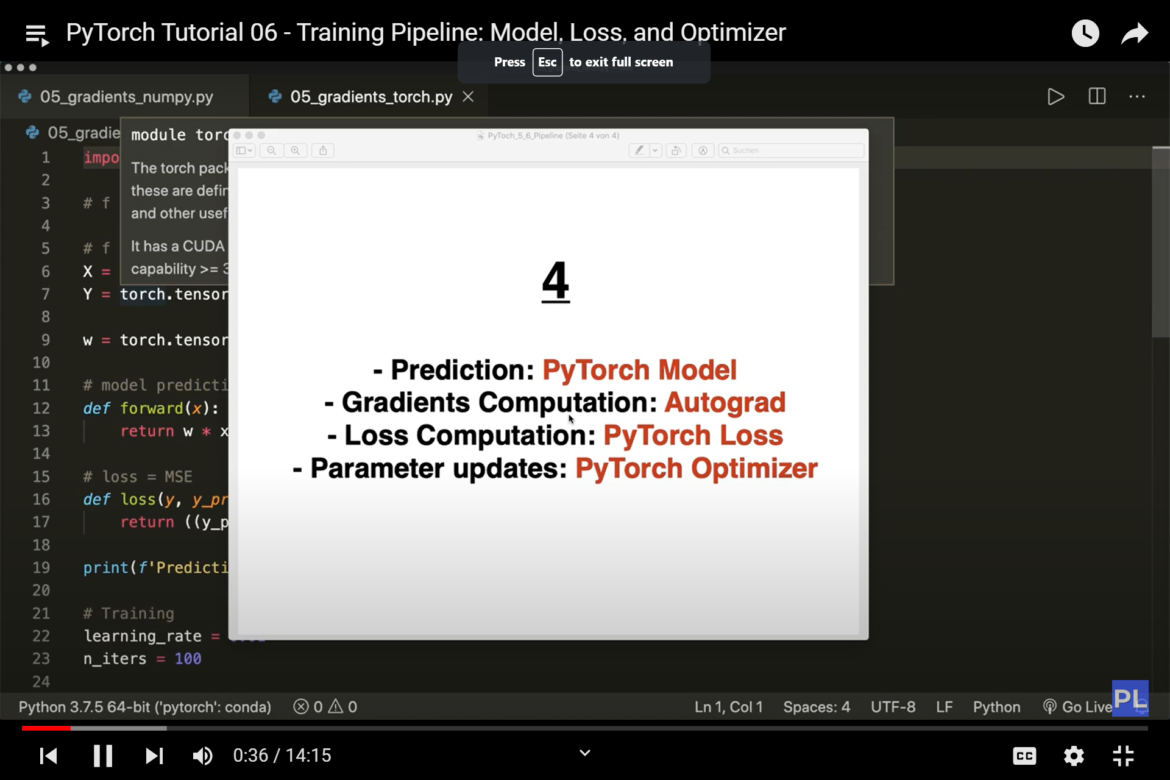

Steps

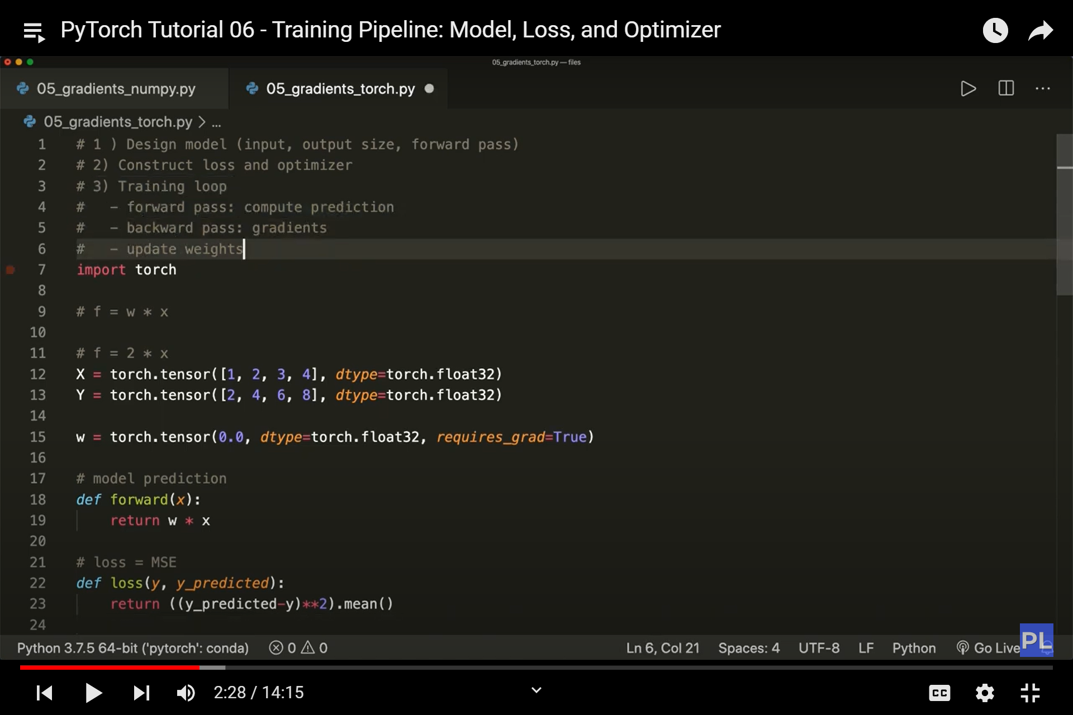

Neural network model

Import torch.nn as nn

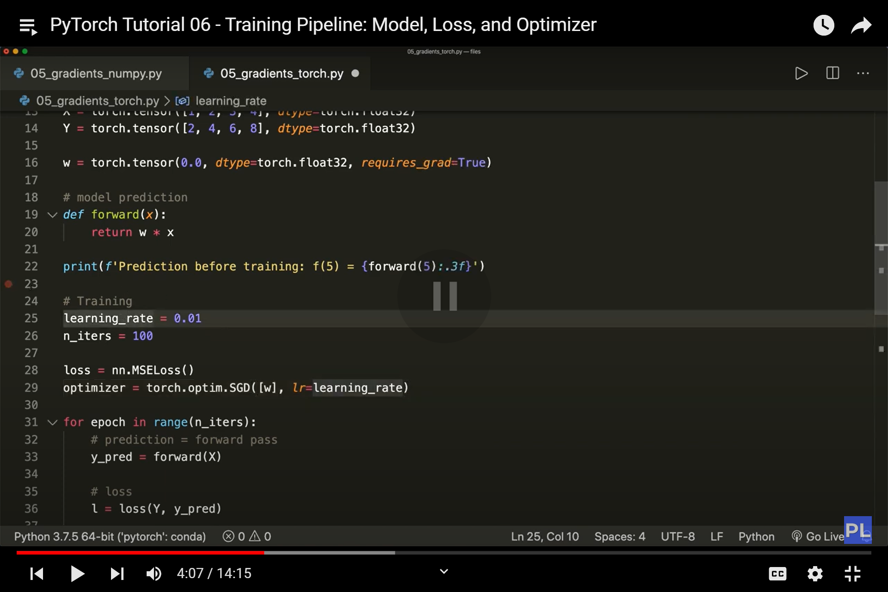

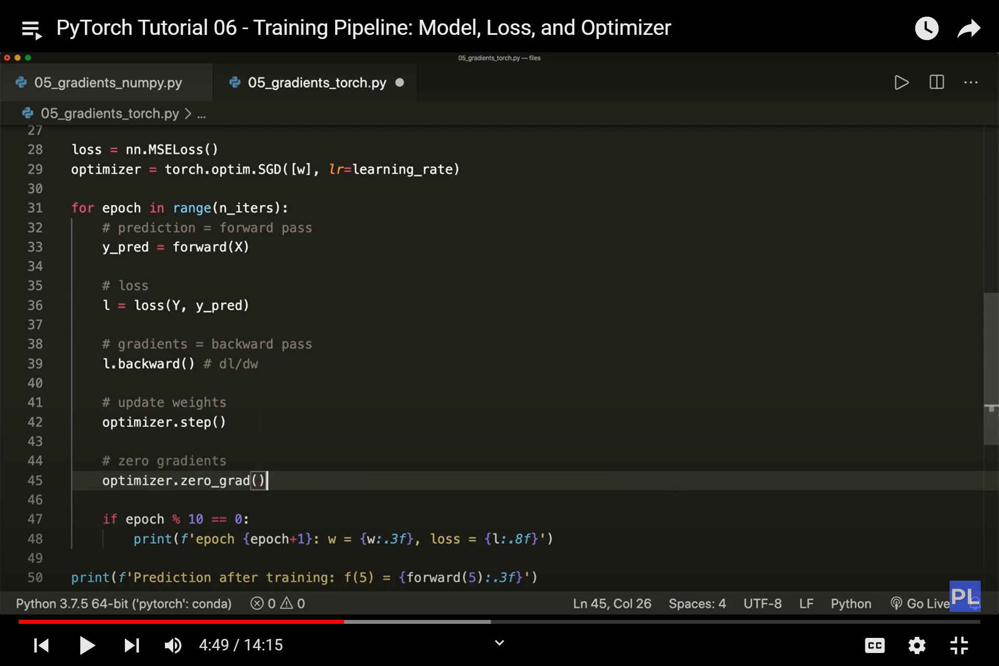

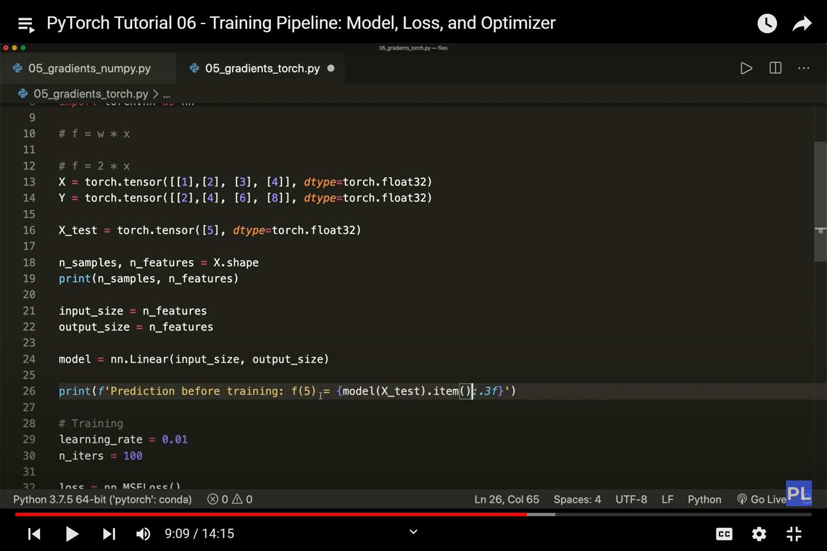

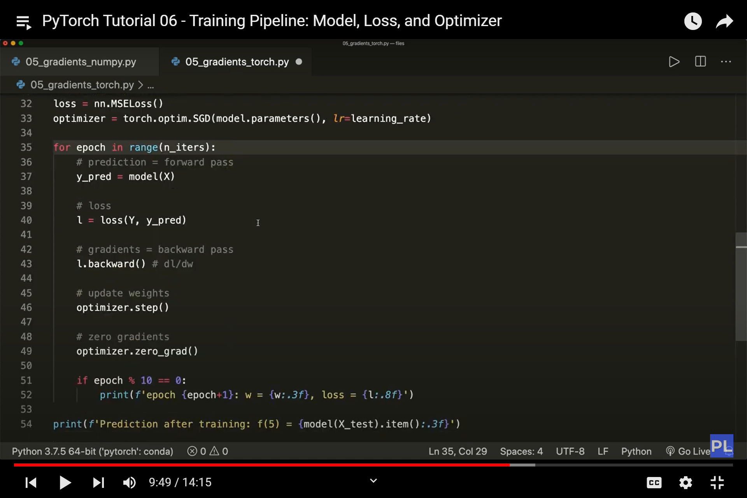

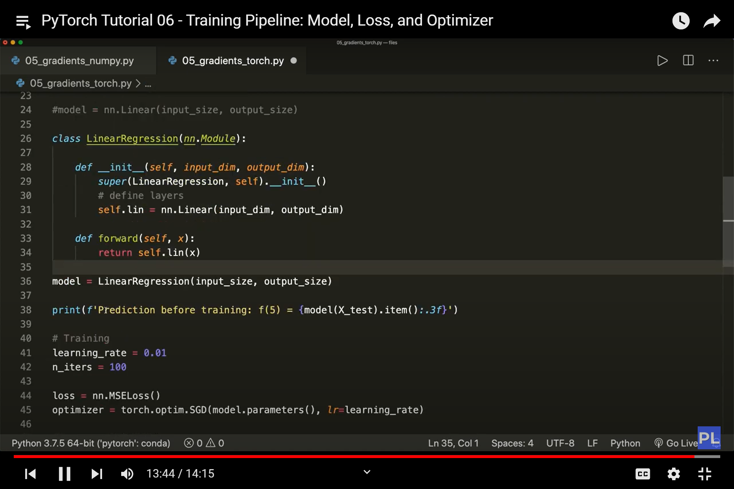

linear regression steps with torch

